Part I:
Create pseudocode that addresses the following. Unary minuses can be added in several ways to the arithmetic expression grammar of Figure 6.17 or Figure 6.18. Revise the BNF and EBNF for each of the cases that follow so that it satisfies the stated rule:
- At most, one unary minus is allowed in each expression, and it must come at the beginning of an expression, so -2 + 3 is legal (and equals 1) and -2 + (-3) is legal, but -2 + -3 is not.
BNF:
<expression> ::= [ "-" ] <term> { "+" <term> | "-" <term> }
<term> ::= <factor> { "*" <factor> | "/" <factor> }
<factor> ::= <number> | "(" <expression> ")"
<number> ::= digit { digit }
<digit> ::= "0" | "1" | "2" | "3" | "4" | "5" | "6" | "7" | "8" | "9"
EBNF:
expression ::= ["-"] term { ("+" | "-") term }
term ::= factor { ("*" | "/") factor }
factor ::= number | "(" expression ")"
number ::= digit { digit }
digit ::= "0" | "1" | "2" | "3" | "4" | "5" | "6" | "7" | "8" | "9"

- At most, one unary minus is allowed before a number or left parenthesis, so -2 + -3 and -2 * -3 are legal, but --2 and -2 + --3 are not.
BNF:
<expression> ::= <term> { "+" <term> | "-" <term> }
<term> ::= <factor> { "*" <factor> | "/" <factor> }
<factor> ::= [ "-" ] (<number> | "(" <expression> ")")
<number> ::= digit { digit }
<digit> ::= "0" | "1" | "2" | "3" | "4" | "5" | "6" | "7" | "8" | "9"

EBNF:
expression ::= term { ("+" | "-") term }
term ::= factor { ("*" | "/") factor }
factor ::= ["-"] (number | "(" expression ")")
number ::= digit { digit }
digit ::= "0" | "1" | "2" | "3" | "4" | "5" | "6" | "7" | "8" | "9"
- Arbitrarily many unary minuses are allowed before numbers and left parentheses, so everything above is legal.
BNF:
<expression> ::= <term> { "+" <term> | "-" <term> }
<term> ::= <factor> { "*" <factor> | "/" <factor> }
<factor> ::= { "-" } (<number> | "(" <expression> ")")
<number> ::= digit { digit }
<digit> ::= "0" | "1" | "2" | "3" | "4" | "5" | "6" | "7" | "8" | "9"
EBNF:
expression ::= term { ("+" | "-") term }
term ::= factor { ("*" | "/") factor }
factor ::= { "-" } (number | "(" expression ")")
number ::= digit { digit }
digit ::= "0" | "1" | "2" | "3" | "4" | "5" | "6" | "7" | "8" | "9"

Pseudocode:

Case 1:
expression:
if next token is '-':
consume '-'
value = term()
return -value
else:
return term()

term:
factor()
while next token is '*' or '+':
consume operator
factor()

factor:
if next token is '(':
consume '('
value = expression()
consume ')'
return value
else:
return number()

Case 2:
Same as case 1 but factor is changed to check if there is a number or parenthesis right before it. If there is, we will flip the sign otherwise we return the number or parenthesis.
read factor:
if there’s a '-':
remember it
read number or parenthesis
flip the sign
else:
read number or parenthesis

Case 3:
This factor will count all “-“ signs in a row before reaching the number or parenthesis and determine if the final sign is positive or negative based on the whether the total count is an odd or even number of “-“ signs.
read factor:
negatives = 0
while there’s a '-':
count it
read number or parenthesis
if count is odd:
flip the sign

Expression: ((2))
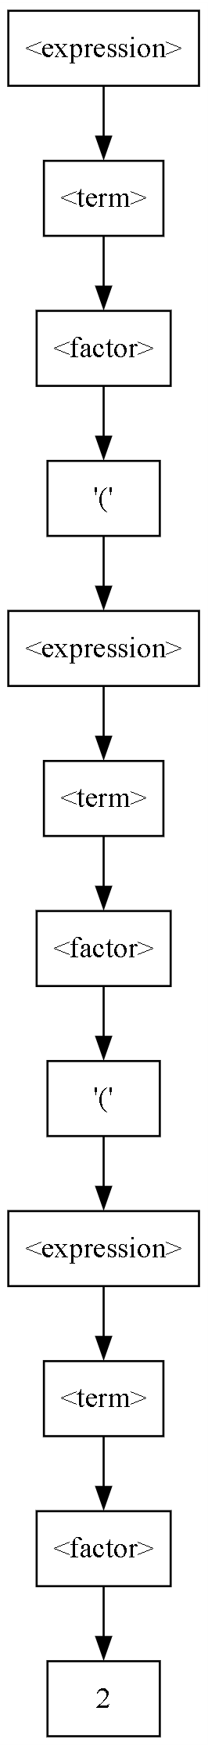
Parse Tree
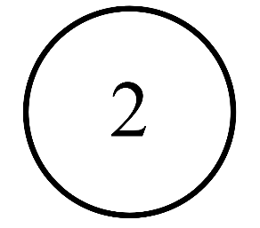
Abstract Syntax Tree

Expression: 3 + 4 * 5 + 6 * 7
Parse Tree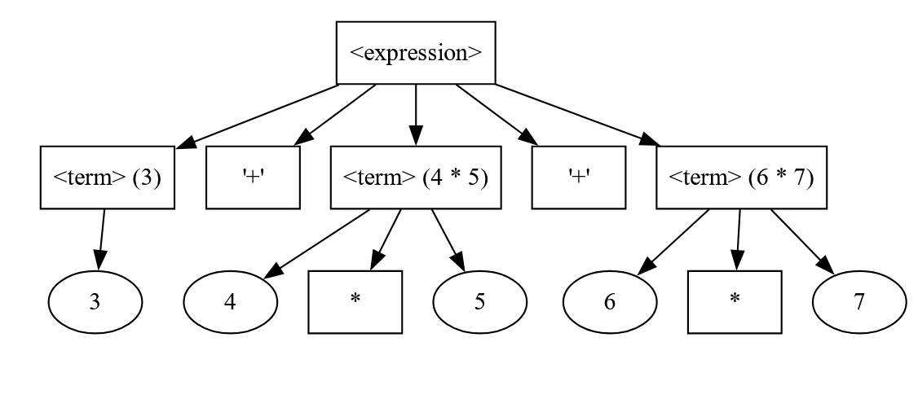
Abstract Syntax Tree:
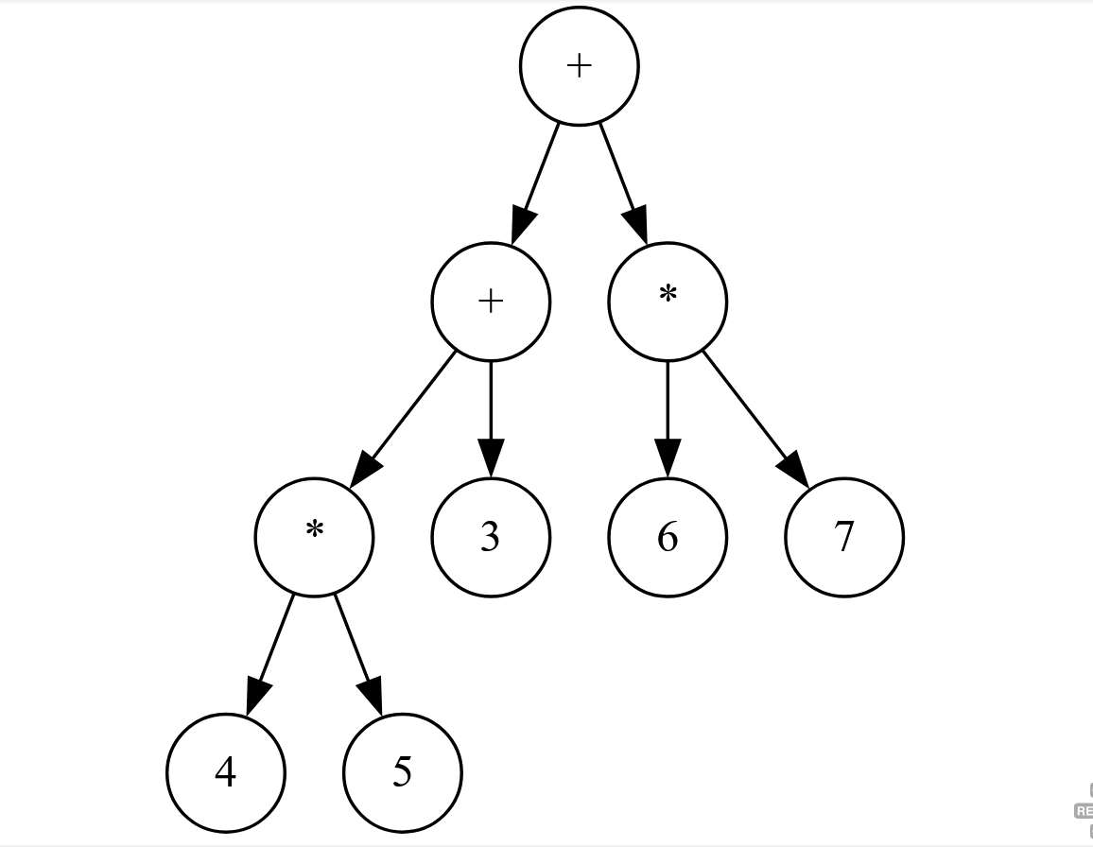
Expression: 3 * 4 + 5 * 6 + 7
Parse Tree:
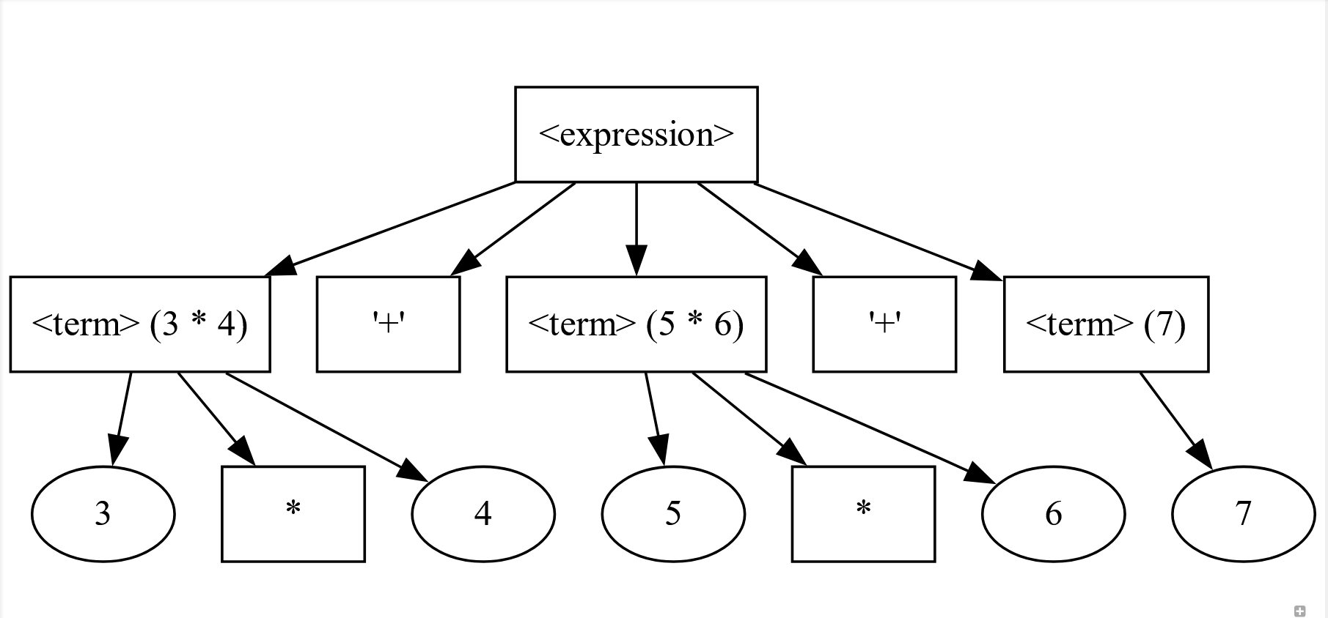
Abstract Syntax Tree:
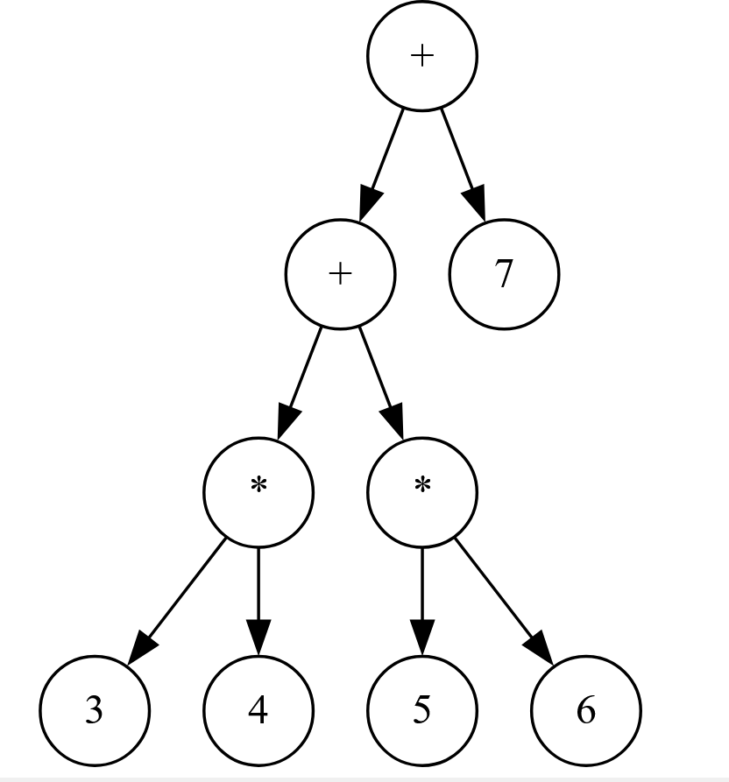

Expression: 3 * (4 + 5) * (6 + 7)
Parse Tree:
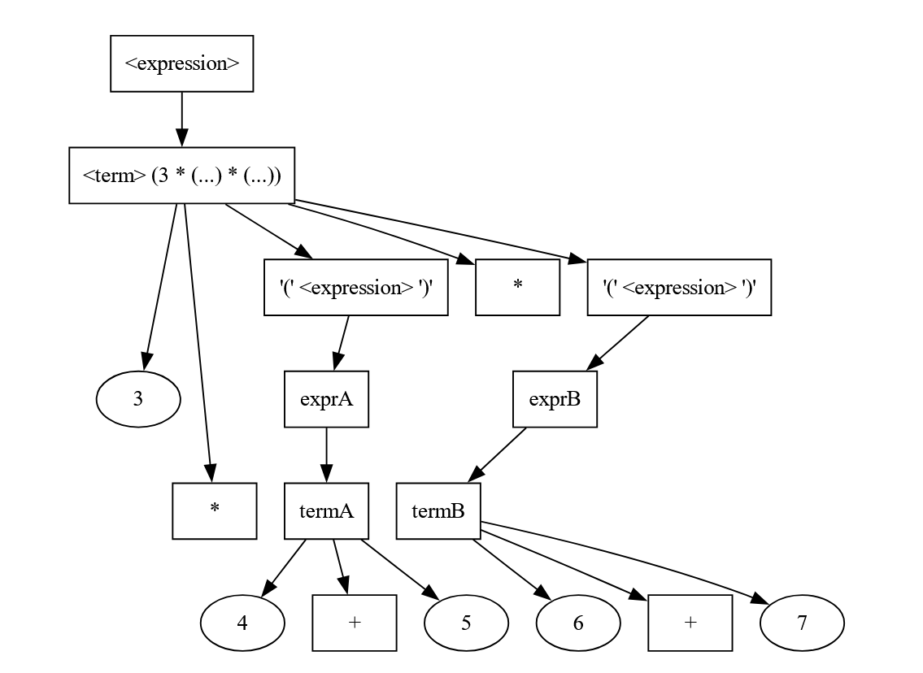
Abstract Syntax Tree:
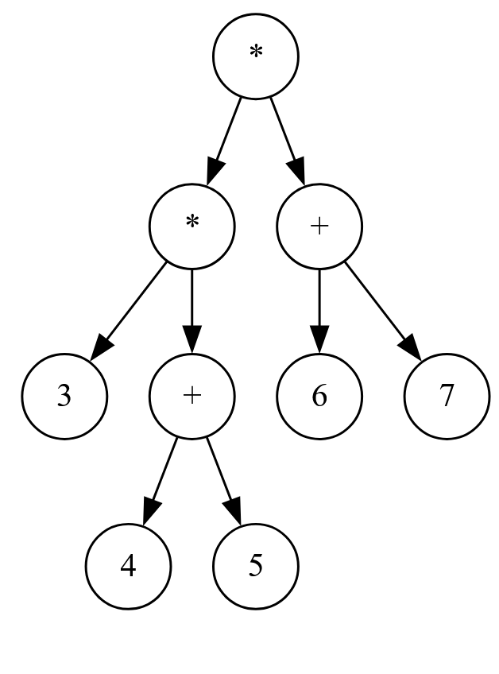

Expression: (2 + (3 + (4 + 5)))
Parse Tree:
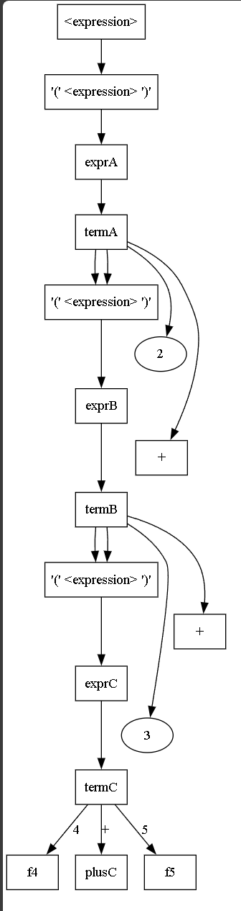
Abstract Syntax Tree:
